**Tutorial 18**

**Name**:Bhavin Patil

**Roll No:** 66

**TY-CS-D**

Study of DOA and DAPP

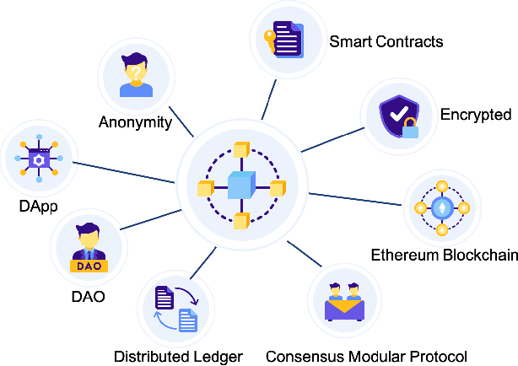

**What are DAO and DApps?**

They are the Decentralized Autonomous Organizations (DAOs) and the Decentralized Applications (DApps). Both come forward strongly and, like blockchain and smart contracts, both have interesting characteristics -some of which are shared with the latter- that will likely make them stay among us.

**DAPPs**

The application must be completely open-source, it must operate autonomously, and with no entity controlling the majority of its tokens. The application may adapt its protocol in response to proposed improvements and market feedback but all changes must be decided by consensus of its users.

The application’s data and records of operation must be cryptographically stored in a public, decentralized blockchain in order to avoid any central points of failure.

The application must use a cryptographic token (bitcoin or a token native to its system) which is necessary for access to the application and any contribution of value from (miners / farmers) should be rewarded in the application’s tokens.

The application must generate tokens according to a standard crytptographic algorithm acting as a proof of the value nodes are contributing to the application (Bitcoin uses the Proof of Work Algorithm).

**DAO**

DAO concept arose from the Ethereum community. DAO concept evolved from a more financial subclass called DAC (Decentralized Autonomous Corporation/Company), which is mainly for translating the human corporation organization into the autonomous computer organization. One example of DAC is “The DAO” which is an investment organization organized using an Ethereum smart contract.

**DApp vs DAO**

Although the two concepts are created by two different groups of people, they are used interchangeably sometimes. The key difference is the word “Autonomous”. DAO could be viewed as one type of DApp, the fully autonomous DApp. DApp is not necessarily DAO.

The current blockchain-based DApps could be viewed as Level 1.5 or 2 automation maximally. It excludes human intervention, but its business logic is pre-fixed and can only be updated through a majority vote; it has no self-learning ability at all.

DAO is supposed to be fully autonomous, which has Level 5 automation. The application should make the decision based on its own intelligence and self-improve from the outcomes of the decisions that it made.No human-created applications reach the “Autonomous” level yet.

DApp does not mention the level of automation. All the examples it gave are the automated software since there is no autonomous software yet. All existing blockchain based DApps including Bitcoin just automate the pre-coded business logic. Vitalik mentioned the DAO as the holy grail since no one yet got there even some may have called themselves “The DAO”.

So DAO is mainly a good vision, not reality (yet).